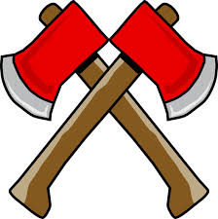 Hatchet Survival Project

CONTEST: IF YOU BUILD IT…

STEP 1: Think about Hatchet. As a group, use the given materials to design and build a survival tool that could have helped Brian in some way. It could be an actual object (a hatchet, for instance if none of you has any creativity) or a completely creative invention. You may use scissors, glue, markers, or pencils. Everything you need for the project will be provided in class.

*YOUR GROUP’S PROJECT MUST INCLUDE A SKETCH OF WHAT YOU PLAN TO CREATE.*

Your final creation can only include these materials:
- 12 popsicle sticks
- 5 paper clips
- posterboard
- 2 pieces of construction paper
- 4 pieces of loose-leaf paper
- 2 feet of duct tape

STEP 2: Present it to us! Each person in the group is responsible for presenting part of the project. Answer the following questions on a notecard, and each group member will present one card.
- Explain what the object is and why you chose to make this particular item. What materials will you use for the project and why?
- How would your object have helped Brian?
- If Brian had chosen to use this item, how would the outcome of the novel changed? Give two different scenarios for this.

STEP 3: Write one paragraph that explains why this particular object would have helped Brian specifically. Refer to actual story elements (plot, setting, or characterization) from Hatchet.

Rubric:
Element of the project | Points Possible | Point Earned
Survival Tool  - Sketch included with 3-D tool  - creativity  - neatness  - relevance to the novel | 35 points
Presentation  - participation  - eye contact / voice projection | 30 points
Paragraph  - explanation of object : why and how it is important  - reference to story elements  - grammar/mechanical errors | 35 points
Total: | 100pts

