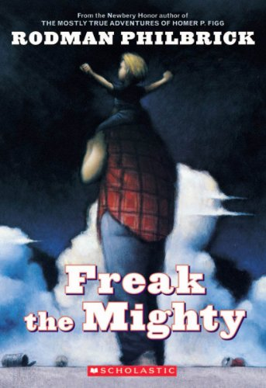
“I never had a brain until Freak came along and let me borrow his for a while, and that’s the truth, the whole truth.”
― Rodman Philbrick, Freak the Mighty
Freak the Mighty Webquest
DIRECTIONS:
1. Follow the directions for Sections 1-4. You should only visit the websites listed for this project. Make sure you have parental permission before you begin.
2. ALL ANSWERS MUST BE WRITTEN IN COMPLETE SENTENCES. No credit will be given for answers that are incomplete sentences or sentence fragments.

*ZERO CREDIT will be given if you plagiarize from the websites or copy from a classmate. Do not copy word for word from the websites. You must take the information you learn and put it in your own words to answer the questions. NO EXCEPTIONS.

3. You should handwrite your responses in COMPLETE SENTENCES.
4. All work for the webquest is due in class on ___________________________________________________.
5. We will work on the laptops in class for two days on this assignment. You will be working in groups to look up the information, but this is an individual grade. Any work not completed at school should be finished at home. It is probably best to do #1 in section 1 and #2 in section 4 at home since you do not need to look up information on the computer to answer those questions.
6. The webquest assignment counts as a major grade for this novel study. No OOPS passes will be accepted for late assignments. Ten points will be deducted per day it is late.

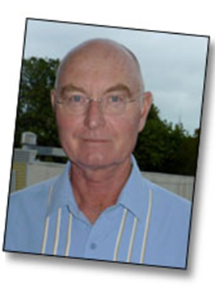
Section 1: Author Study
Rodman Philbrick has written both adult and young adult novels. He is
considered a successful author because of his creative stories
and relatable characters.

Click here to learn more about Rodman Philbrick.
http://www.rodmanphilbrick.com
Answer the questions from the information you learn.
(HINT: Focus on the INFO, BOOKS, and TOP TEN QUESTIONS tabs.)

1. Where did Rodman Philbrick grown up? _______________________________________________
___________________________________________________________________________________
2. According to him, what was his inspiration for Freak the Mighty?
______________________________________________________________________________________________________________________________________________________________________
3. What did you learn about the movie version of this novel?_________________________________
______________________________________________________________________________________________________________________________________________________________________
4. Name three other young adult books written by Philbrick. _________________________________
___________________________________________________________________________________
5. According to his website, when did Philbrick begin writing? ________________________________
_________________________________________________________________________________________________________________________________________________________________________________________________________________________________________________________
6. On a separate sheet of paper, write a well-developed paragraph explaining the most important things you think authors must do to keep readers interested in their writing. Be sure to include a topic sentence, reasons with supporting details, and a concluding sentence. Your paragraph should be 8-12 sentences in length. Staple this paragraph to your handouts and turn in.

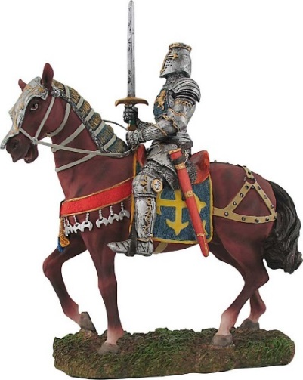
Section 2: Quests and Chivalry
Kevin teaches Max about knights, noble quests, and acts
of chivalry. His ideas come from legends about
King Arthur and the Knights of the Round Table.
Click here to answer these questions.
http://chivalrytoday.com/what-chivalry
1. Based on your reading, write your own definition of what “chivalry” means.
_________________________________________________________________________________________________________________________________________________________________________________________________________________________________________________________
2. Give three modern day examples of how someone might act in a chivalrous way.
_________________________________________________________________________________________________________________________________________________________________________________________________________________________________________________________
Click here to read about King Arthur and the Knights of the Round Table.
http://www.earlybritishkingdoms.com/kids/arthur_life.html
You should follow the links at the bottom of the website and follow the timeline of Arthur’s life.
3. Explain why Arthur did not know who his parents were. ___________________________________
___________________________________________________________________________________
4. Explain the legend of the Sword and the Stone. __________________________________________
___________________________________________________________________________________
___________________________________________________________________________________
5. What is Excalibur and where did King Arthur get it? ______________________________________
___________________________________________________________________________________
6. What was special about Excalibur? ____________________________________________________
___________________________________________________________________________________
7. Who was Guinevere?_______________________________________________________________
8. Give two reasons that explain the significance of the Round Table.___________________________
___________________________________________________________________________________

Section 3: Morquio Syndrome
In the story, Kevin suffers from a genetic disease called Morquio Syndrome.
Click here to visit a medical website to learn about this disease.
http://www.nlm.nih.gov/medlineplus/ency/article/001206.htm

1. In your own words, what causes Morquio Syndrome?
2. Name three symptoms that could affect people with this disease.
3. Explain the treatment options for Morquio Syndrome.
4. Name three complications that are caused by Morquio Syndrome?

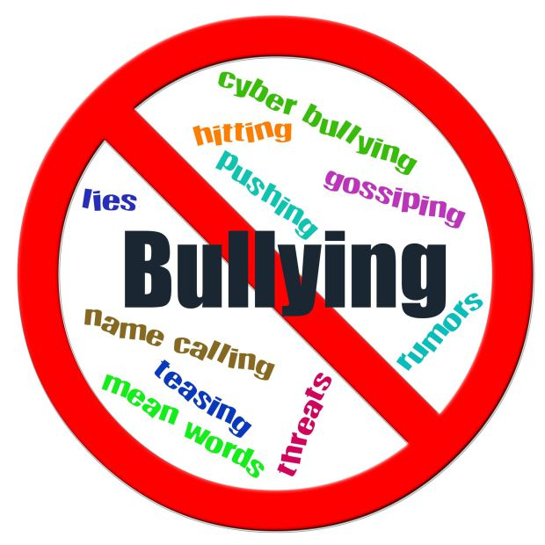
Section 4: Bullying
Bullying is a major conflict in the novel.
1. What is your definition of bullying?

Click here to learn more about this issue.
http://www.stopbullying.gov/prevention/index.html

2. In a well-developed paragraph, explain three ways people could prevent bullying. Be sure to include a topic sentence, reasons with supporting details, and a concluding sentence. Your paragraph should be 8-10 sentences in length.

Webquest Grading Rubric
Section 1  - answers written in complete sentences  - answers are clear and concise  - paragraph writing - well written; on topic; directions followed | 5 points per question  10 points paragraph | ______/15  ______/10 ______/25
Section 2  - answers written in complete sentences  - answers are clear and concise | 3.1 points per question | ______/25
Section 3  - answers written in complete sentences  - answers are clear and concise | 3 points per question | _______/12
Section 4  - answer written in complete sentences  - answers are clear and concise  - paragraph writing – well written; on topic; directions followed | 3 points for question  10 points paragraph | ______/3  _____/10
Mechanics | correct grammar usage  -capitalization, punctuation, correct word usage | ______/15
Directions | -answers show evidence from research  -headings are correctly labeled  -all directions for assignment followed | _____/10
Final Grade |  | _____/100

Comments:

Resources List
1. Author Study
http://www.rodmanphilbrick.com
http://www.scholastic.com/teacher/videos/teacher-videos.htm?bctid=3017210237001&bclid=3193530838001&active=1

2. Quests and Chivalry
http://chivalrytoday.com/what-chivalry/
http://www.earlybritishkingdoms.com/kids/arthur_life.html

3. Morquio Syndrome
http://www.nlm.nih.gov/medlineplus/ency/article/001206.htm

4. Bullying
http://www.stopbullying.gov/prevention/index.html

