Directions: Identify whether the author’s purpose of each infographic is to persuade, to inform, to entertain, to explain, or to describe. Each example may have more than one purpose.

- The author’s purpose is to _______________________________________________.
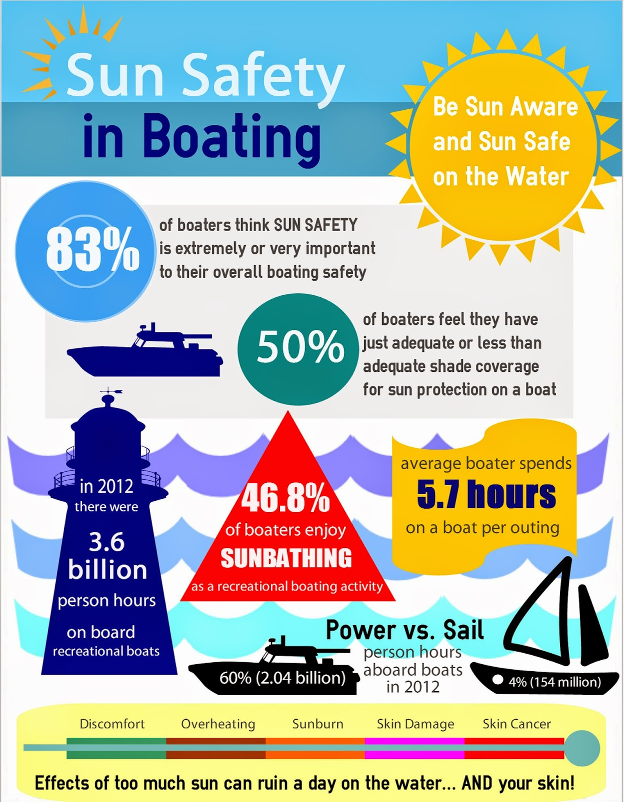

2. The author’s purpose is to ________________

_______________________________________.
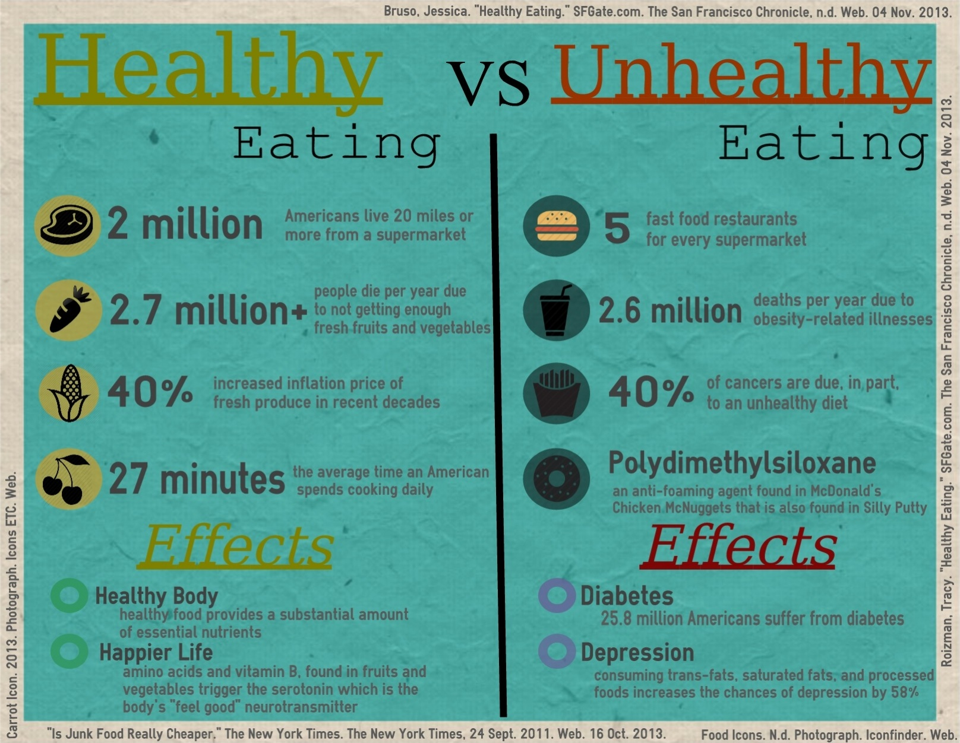

3. The author’s purpose is to _______________________________________________.

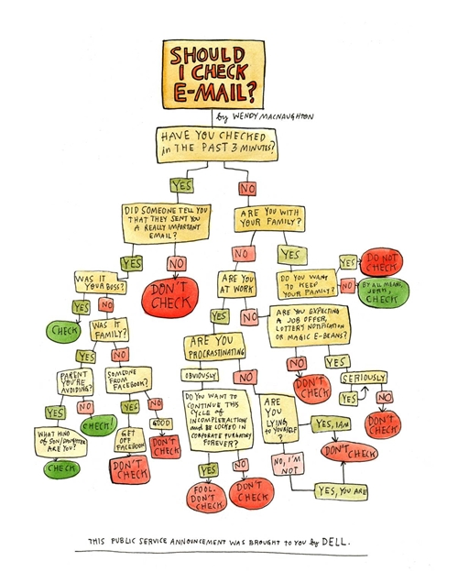

4. The author’s purpose is to _______________

_____________________________________.

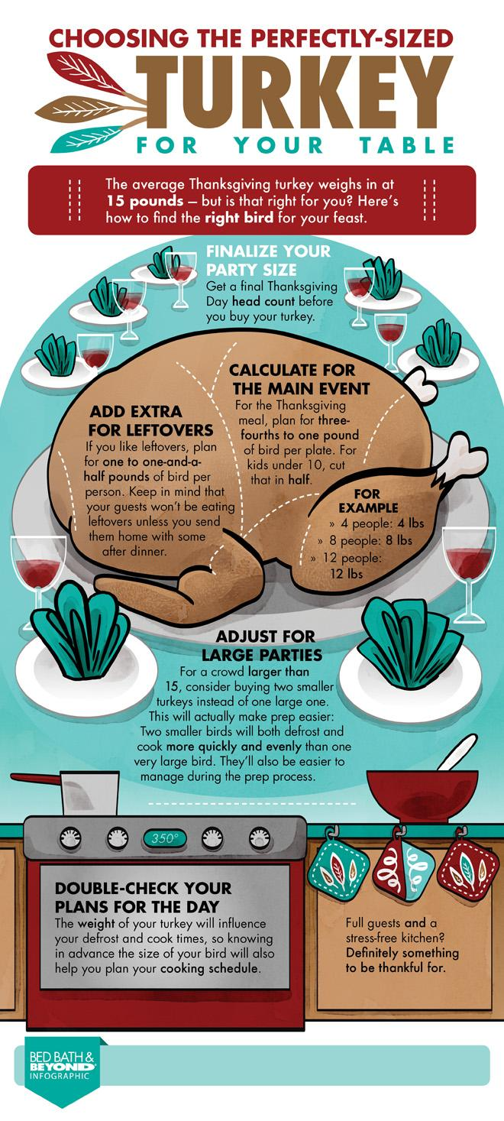

5. The author’s purpose is to _________________

_______________________________________.

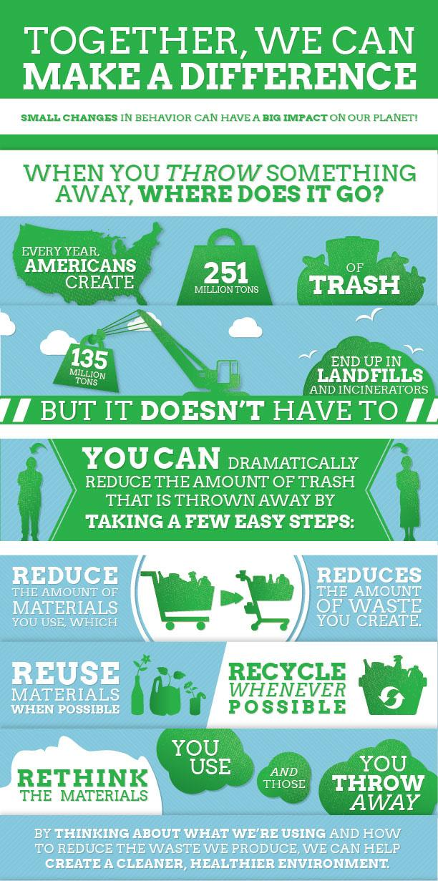

6. The author’s purpose is to ___________

__________________________________.

7. The author’s purpose is to ______________________________________________________.
8. The author’s purpose is to

_________________

_________________

________________.

