**20 Most Common Grammar Errors**

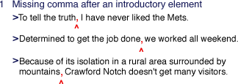

Macintosh HD:private:var:folders:3r:hg5s2v4n04j2qb00mmsmxwk00000gn:T:TemporaryItems:pron1.gif

http://bcs.bedfordstmartins.com/everyday_writer/20errors/img/pron2.gif   
  
What is being limited—the signals or the airwaves?

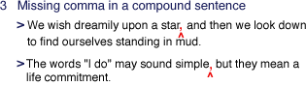

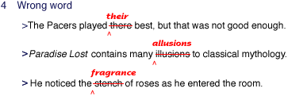

Macintosh HD:private:var:folders:3r:hg5s2v4n04j2qb00mmsmxwk00000gn:T:TemporaryItems:faq5nonres2.gif

Macintosh HD:private:var:folders:3r:hg5s2v4n04j2qb00mmsmxwk00000gn:T:TemporaryItems:faq5nonres1.gif

Macintosh HD:private:var:folders:3r:hg5s2v4n04j2qb00mmsmxwk00000gn:T:TemporaryItems:faq5nonres3.gif

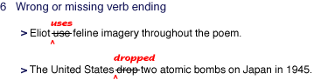

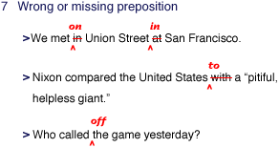

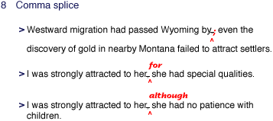

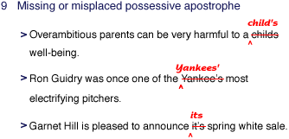

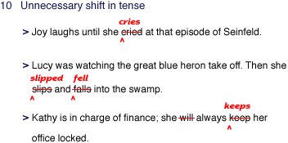

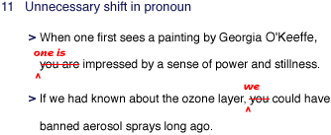

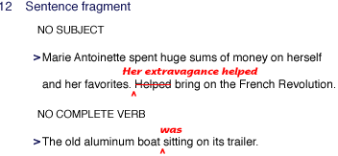

Macintosh HD:private:var:folders:3r:hg5s2v4n04j2qb00mmsmxwk00000gn:T:TemporaryItems:faq13tense1.gif

Macintosh HD:private:var:folders:3r:hg5s2v4n04j2qb00mmsmxwk00000gn:T:TemporaryItems:faq14subj3.gif

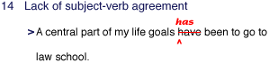

Macintosh HD:private:var:folders:3r:hg5s2v4n04j2qb00mmsmxwk00000gn:T:TemporaryItems:faq15series.gif

Macintosh HD:private:var:folders:3r:hg5s2v4n04j2qb00mmsmxwk00000gn:T:TemporaryItems:faq16agreehead.gif

Macintosh HD:private:var:folders:3r:hg5s2v4n04j2qb00mmsmxwk00000gn:T:TemporaryItems:faq16agree1.gif

Macintosh HD:private:var:folders:3r:hg5s2v4n04j2qb00mmsmxwk00000gn:T:TemporaryItems:faq16agree2.gif

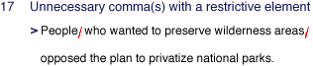

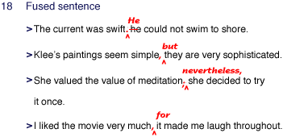

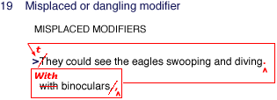

Who was wearing the binoculars—the eagles?

